Cross Curricular American Literature Unit: The Crucible

Part 1

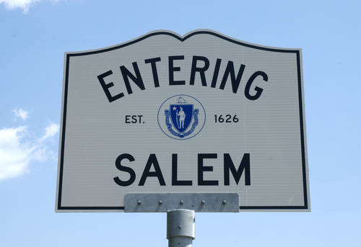

This artifact study is designed to work in conjunction with a multimedia unit based on The Crucible by Arthur Miller. The following activities will incorporate art history, history, journalism and political science into an American literature/ English unit. By utilizing primary sources from history, the students will be able to compare the witch hunts in Salem to those that occurred during the second Red Scare- when the play was written.

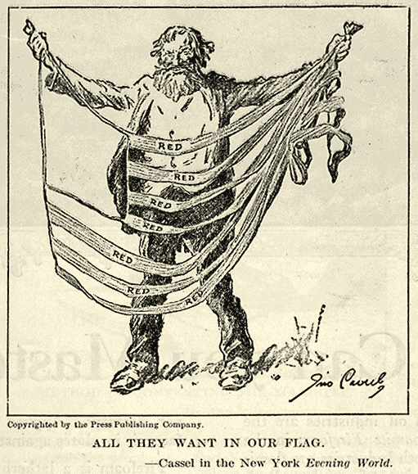
Political Satire from “Red Scare” America

(…incorporating political science and journalism into the lesson.)

Observations: What do you see in this picture?

1.

2.

3.

4.

5. Based on the picture, what is the goal of the “reds”?

6. Looking at the picture, what stereotypes, if any can be seen?

7. Why was the “Red Scare” able to take a foothold in American in the 1940s and 1950s? What were the political situations which allowed it to happen?

8. Are there any modern versions of this type of fear and hatred being propagated by the media?

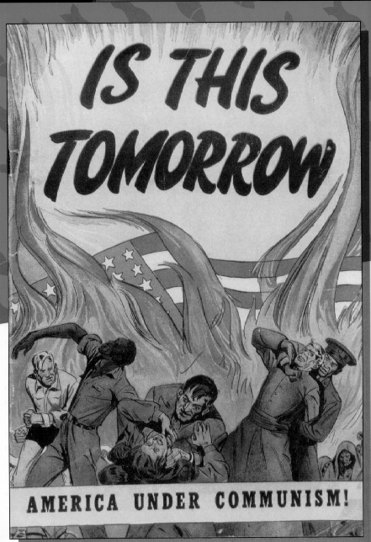
Political Satire from “Red Scare” America

(…incorporating political science and journalism into the lesson.)

Observations: What do you see in this picture?
1.

2.

3.

4.

5. Based on the picture, what is the goal of the “reds”?

6. Looking at the picture, what stereotypes, if any can be seen?

7. Based on the picture, what would “America Under Communism” be like? Explain.
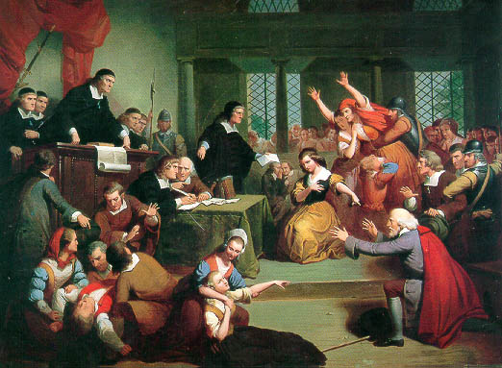
Comparing the Court Rooms
(…incorporating art history and photography into the lesson.)

Observations: What do you see in these pictures?
1.

2.
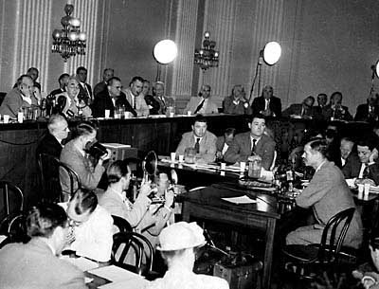

3.

4.

What are the main similarities and differences between the two courtroom images?

How does the painter use color to bring the image of Salem alive?

Why do you think that the painter uses the color red so prominently?

What do you think is going on in the courtroom in the picture on the bottom? (This is a trial by the House Un-American Activities Committee.) Include the details as to WHY you answered the way that you did.

